Cucumber-BDD Framework

TDD-Test Driven Development

BDD-Behaviourl Driven Devlopment.

Gherkin

Cucumber-JVM/Ruby

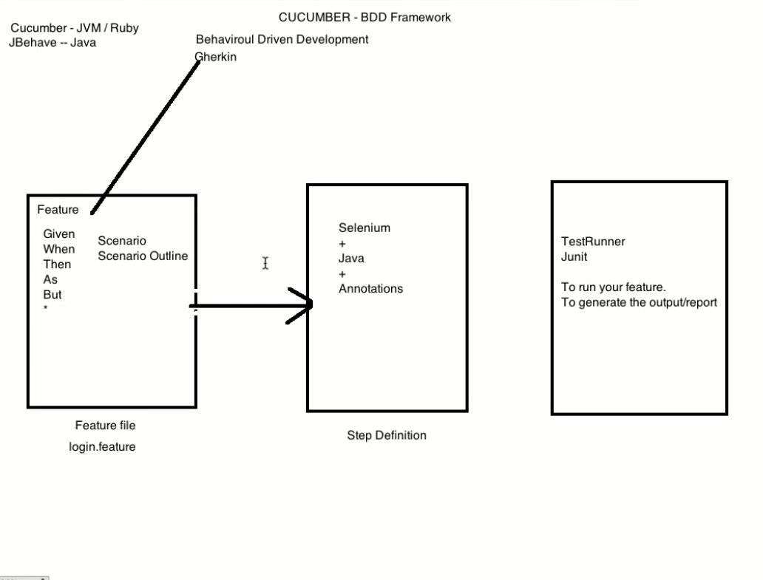

1. Create new Maven Project with Group ID and Artifact ID.

